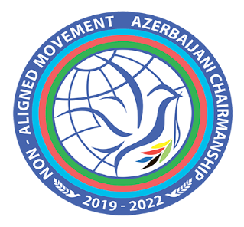

Application Form for
Online International Model
Non-Aligned Movement Simulation Exercise
Dedicated to the 60th Anniversary of the Non-Aligned Movement
1-5 March 2021

- Name and Surname:

- Nationality:

- Gender:

- Date of birth:

- E-mail address:

- Contact Number:

- Current affiliation (workplace / name of educational institution):

- Study field:

- Do you have any experience in simulation exercises? If yes, please indicate the conference, year and the role you performed:

- What are your motivation and expectation for participating in the simulation exercise (please, explain briefly min. 100 – max. 300 words)?

- How do you see the role of the Non-Aligned Movement in strengthening multilateralism? (please, explain briefly min.100 - max. 300 words)?

- How do you think the Chairmanship of Azerbaijan to the Non-Aligned Movement can contribute to this process (please, describe briefly min.100 - max. 300 words)?

- How do you see the role of the youth in advancing the values and principles of the Non-Aligned Movement (please, describe briefly min.100 - max. 300 words)?

- Have you ever attended the web-based event? If yes, which one and how was your impression?

- Do you have the following technical capabilities to attend the event? (please put “+” or “-” signs after each option)

- Web-camera
- Microphone
- Zoom software
- High-speed internet connection

PLEASE, SEND THE FILLED APPLICATION TO THE FOLLOWING EMAIL ADDRESS: nammodel@mfa.gov.az

